CO3-ASSISSMENT TOOL-1
COURSE CODE: CSA1007
COURSE NAME: SOFTWARE ENGINEERING
NAME: P ROHINI
REG NO: 192524147

35) Smart Urban Traffic Congestion Prediction and Signal Optimization Platform
Industry Context
The transportation sector is rapidly adopting digital technologies to improve efficiency, safety, scalability, and decision making. Traditional approaches often rely on manual processes and reactive monitoring, resulting in delays, increased operational costs, resource wastage, and reduced service quality. There is a growing need for an intelligent, cloud-enabled, distributed platform capable of collecting real-time IoT and enterprise data, analyzing operational conditions, predicting risks, and supporting timely interventions.
Problem Statement
Design and develop a distributed Smart Urban Traffic Congestion Prediction and Signal Optimization Platform that continuously acquires real-time operational data from connected devices, enterprise systems, and users. The platform should detect abnormal events, generate predictive insights using AI/ML, notify stakeholders in real time, provide centralized dashboards, generate reports, and support secure, scalable, fault-tolerant operation across multiple locations.

Objectives
• Collect real-time operational data.
• Monitor system performance continuously.
• Detect anomalies automatically.
• Predict failures or risks using analytics.
• Notify stakeholders immediately.
• Generate dashboards and reports.

Git & Docker Technical Assignment
Title
Smart Urban Traffic Congestion Prediction and Signal Optimization Platform
1. Problem Analysis
Problem Statement
The proposed platform collects real-time traffic data from IoT devices, connected systems, and users. It analyzes the data to detect abnormal traffic conditions, predict congestion, support signal optimization, and provide alerts, dashboards, and reports.
Objectives
- Collect real-time traffic data.
- Monitor traffic continuously.
- Detect abnormal conditions.
- Predict traffic congestion.
- Optimize traffic signals.
- Send real-time alerts.
- Generate dashboards and reports.
- Provide secure and scalable operation.
Expected Outcomes
- Reduced traffic congestion and delays.
- Faster decision-making.
- Better resource utilization.
- Improved service reliability.
- Support for multiple locations.
2. Project Structure Design
Smart-Traffic-Platform/
│
├── frontend/
├── backend/
├── ml-model/
├── database/
├── tests/
├── Dockerfile
├── docker-compose.yml
├── .gitignore
└── README.md

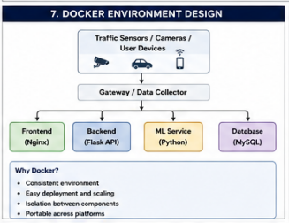

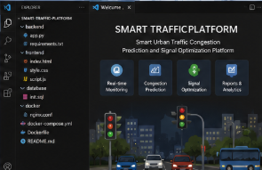

3. Git Repository Initialization

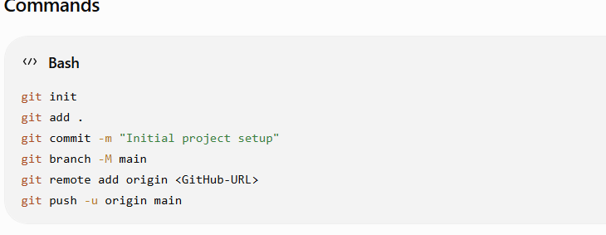

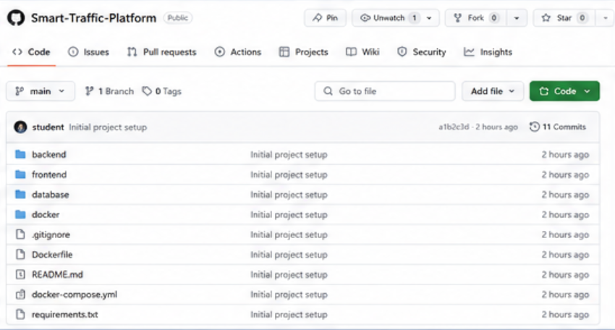

4. Git Branching Strategy
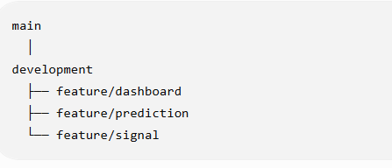
- main – Stable version.
- development – Testing and integration.
- feature – Individual feature development.
This makes development organized and reduces conflicts.
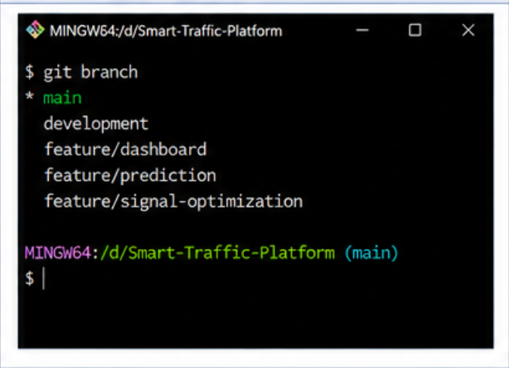
5. Version Control Workflow
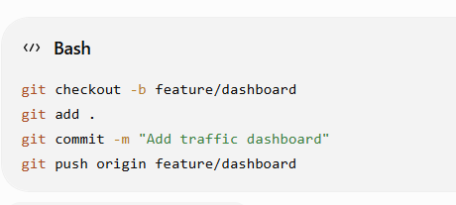
6. Commit History
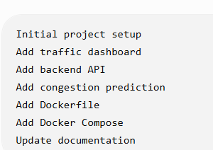
7. Dockerfile
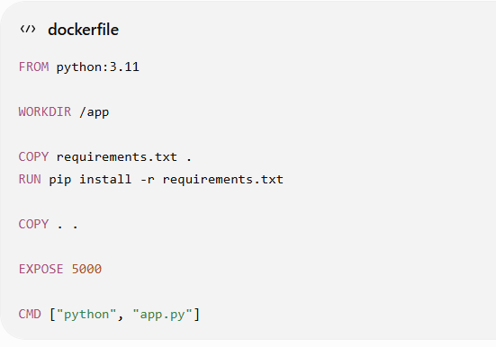
8. Benefits
Git
- Version control.
- Collaboration.
- Branching.
- Change tracking.
Docker
- Portability.
- Easy deployment.
- Isolation.
- Scalability.
- Maintainability.
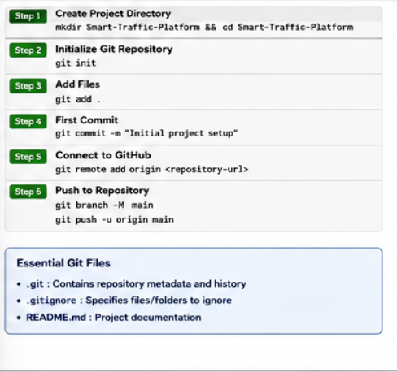
9. Deployment and Testing
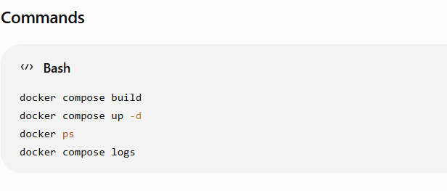
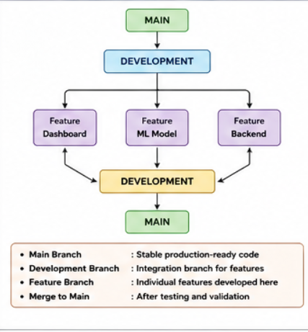
Testing
Check whether:
- Website opens.
- Backend works.
- Database connects.
- Traffic data is displayed.
- Dashboard works.
- Containers communicate correctly.
12. Challenges and Future Improvements
Challenges
- Handling real-time traffic data.
- Managing multiple services.
- Git merge conflicts.
- Docker configuration.
- Supporting multiple locations.
Future Improvements
- IoT integration.
- Advanced AI/ML prediction.
- Automatic signal control.
- Cloud deployment.
- Mobile application.
- Real-time notifications.

Conclusion
The Smart Urban Traffic Platform uses Git for version control and Docker for containerized deployment. The system helps monitor traffic, predict congestion, optimize signals, and support faster decision-making.

OUTPUT:
